AUTOMATIC CLASSIFICATION OF CRIME-RELATED TEXT REPORTS USING NLP
CHAPTERS III, IV & V
Methodology | Implementation and Results | Discussion and Conclusion
YAASIIN MOHAMUUD ABDULLAAHI
NAIMA ABDIAZIZ SAID
NASTEHA MOHAMUUD MOHAMED
NAJMA MUHIDIIN MOHAMED

JAMHURIYA UNIVERSITY OF SCIENCE AND TECHNOLOGY (JUST)
FACULTY OF COMPUTER & INFORMATION TECHNOLOGY
AUGUST 2026

CONTENTS
CHAPTER III: METHODOLOGY 1
3.1 Introduction 1
3.2 System Overview 2
3.3 System Features 2
3.4 System Architecture 4
3.5 Data Acquisition and Preprocessing 5
3.6 Feature Engineering / Representation 6
3.7 Model / Algorithm Development 7
3.8 Requirements 9
3.9 Feasibility Study 11
3.10 System Design 12
CHAPTER IV: IMPLEMENTATION AND RESULTS 14
4.1 Dataset Description 14
4.2 ML Pipeline Implementation 15
4.3 System Design and Deployment 16
4.4 Data Visualization (Results Presentation) 19
4.5 Model Comparison 21
CHAPTER V: DISCUSSION AND CONCLUSION 23
5.1 Introduction 23
5.2 Interpretation of Results 23
5.3 Contribution to Knowledge 24
5.4 Challenges and Limitations 25
5.5 Future Work 25
5.6 Final Conclusion 26
APPENDIX A: FIGURE INDEX 28
APPENDIX B: TABLE INDEX 29
REFERENCES 30

CHAPTER III: METHODOLOGY

3.1 Introduction
This chapter presents the methodology used to design and develop BAREAI, an Artificial Intelligence based platform for the automatic classification of crime-related text reports using Natural Language Processing (NLP). The chapter describes the system overview, features, architecture, data acquisition and preprocessing procedures, feature engineering techniques, machine learning algorithms, evaluation metrics, system requirements, feasibility study, and system design. The methodology follows the Artificial Intelligence Final Year Project (FYP) guideline of the Faculty of Computer and Information Technology, Jamhuriya University of Science and Technology (JUST).
The research problem addressed by this study is the heavy dependence of Somali security agencies on manual sorting of digital crime reports. Manual triage is slow, inconsistent, and difficult to scale when reports arrive from social media, websites, emails, and online forms. Therefore, the methodology combines classical supervised machine learning with a production-ready web application that supports investigators through automated classification, case dispatch, and monitoring.

3.2 System Overview
BAREAI (Intelligence Platform) is a three-tier web-based system that automatically determines whether an input text is crime-related or not crime-related. Users may submit free text, upload PDF/DOCX/TXT files, or provide URLs. In addition, the platform monitors blacklisted Facebook pages and websites, classifies newly collected content, and creates investigation cases when crime-related content is detected.
The system separates concerns across three services: (1) a React single-page application for presentation; (2) a Node.js/Express REST API for authentication, business logic, monitoring, and persistence; and (3) a Flask NLP microservice that loads a trained Random Forest classifier and TF-IDF vectorizer for inference. MongoDB stores users, analysis history, investigation cases, blacklist items, notifications, and audit logs. Role-based access control distinguishes Admin, Investigator, and Public User roles.

3.3 System Features

3.3.1 Authentication and Authorization
BAREAI implements secure registration and login with JSON Web Tokens (JWT). Email OTP verification strengthens account security. Investigators may be created by administrators with forced password change on first login. Roles restrict access to dashboards, case tools, blacklist management, and audit logs.

3.3.2 Automated Crime Text Classification
The core feature accepts Somali (and mixed) text reports and returns a binary prediction (crime-related / not crime-related), confidence score, optional matched keywords, and extracted location mentions. Classification is performed by the Flask NLP service and may be reinforced by Somali crime-keyword heuristics to reduce false negatives for high-risk phrases.

3.3.3 Multi-Source Input Analysis
Users can analyse: (a) pasted text; (b) webpage URLs extracted with HTML parsing; (c) uploaded documents (PDF, DOCX, TXT); and (d) batch submissions. Guest users are limited to a small number of free analyses to protect computational resources.

3.3.4 Blacklist Monitoring
Administrators and investigators maintain a watchlist of Facebook pages, websites, keywords, and persons. Facebook pages can be scanned periodically using automated browser scraping. Website pages can be scanned on demand. Detected crime content generates alerts and investigation cases.

3.3.5 Case Management and Notifications
When crime-related content is confirmed, the system creates a pending investigation case and notifies available investigators. The first investigator to accept the case claims ownership. Investigators can update status, write findings, submit formal reports, and flag false or malicious reports for administrative review.

3.3.6 Dashboard, Reports, and Audit Logging
The admin dashboard summarises analyses, detected crimes, users, investigators, blacklist items, and active cases. Operational reports and activity logs support accountability and organisational oversight.

3.4 System Architecture
BAREAI follows a modular three-tier architecture. The presentation layer is a React application built with Vite and Tailwind CSS. The application layer is an Express API that validates requests, enforces authentication, orchestrates monitors, and persists results. The intelligence layer is a Flask service hosting the serialised Random Forest model and TF-IDF vectorizer. The data layer is MongoDB.
Typical data flow: User Input → Express Validation and Text Extraction → Flask /predict Inference → Keyword and Location Enrichment → History Persistence → Optional Case Dispatch and Notifications → Result Display.

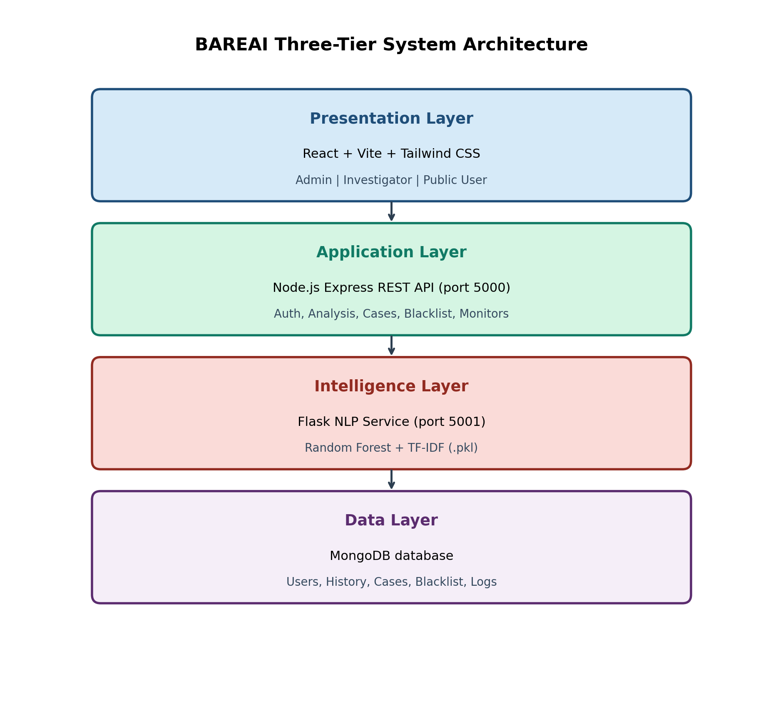
Figure 3.1: System Architecture of the BAREAI Crime Classification Platform

3.5 Data Acquisition and Preprocessing

3.5.1 Dataset Source
The experimental dataset contains 9,999 labelled text samples stored in CSV format. Each record includes a source URL, the raw text body, and a binary category label: crime-related or not crime-related. The corpus is nearly balanced (5,000 crime-related and 4,999 not crime-related). Sources are predominantly Somali-language news and social-media style texts (for example BBC Somali and related outlets), manually labelled for supervised learning.
Table 3.1: Dataset Column Description and Summary Statistics
Attribute | Description
url | Source link of the collected text
text | Raw report / article / post content
category | Binary label: crime-related or not crime-related
Total samples | 9,999
Crime-related | 5,000 (50.01%)
Not crime-related | 4,999 (49.99%)
Average length | Approximately 1,787 characters / 277 words

3.5.2 Data Preprocessing Steps
Preprocessing was implemented in a Jupyter notebook prior to model training. The pipeline removes incomplete rows, normalises casing, strips URLs and emails, retains Latin and Arabic script characters relevant to Somali orthography, collapses excess whitespace, tokenises by whitespace, and removes Somali stopwords (approximately 284 stopwords when an external stopword list is available; otherwise a built-in fallback list is used).

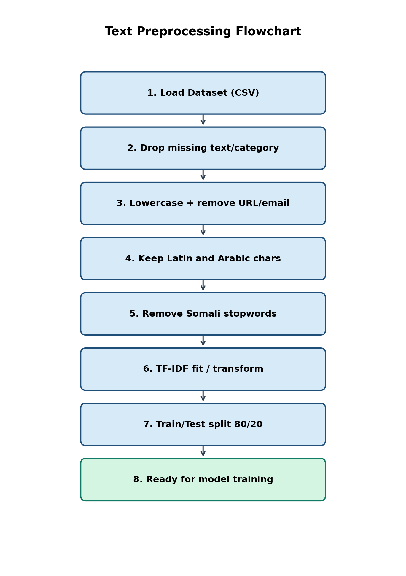
Figure 3.2: Text Preprocessing Flowchart

3.6 Feature Engineering / Representation
Text was transformed into numerical features using Term Frequency–Inverse Document Frequency (TF-IDF). During experimentation, TF-IDF and Bag-of-Words representations were compared with constrained vocabulary settings. For the notebook experiments, TF-IDF used max_features=300, min_df=2, max_df=0.95, and ngram_range=(1,2). The deployed production vectorizer uses a larger vocabulary (max_features=5000) to improve coverage during live inference.
The dataset was split into training (80%) and testing (20%) subsets using stratified sampling with random_state=42, yielding 7,999 training samples and 2,000 test samples (1,000 per class in the test set). Stratification preserved class balance and enabled fair comparison across classifiers.
Table 3.2: Feature Engineering and Split Configuration
Item | Configuration
Feature method | TF-IDF (primary); Bag-of-Words (experimental)
Notebook TF-IDF | max_features=300, ngram_range=(1,2)
Deployed TF-IDF | max_features=5000, unigrams
Train/Test split | 80% / 20%, stratified
Random state | 42
Target classes | crime-related, not crime-related

3.7 Model / Algorithm Development

3.7.1 Baseline Model and Model Selection
Multiple supervised classifiers were trained as baselines and candidates for deployment: Random Forest, Gradient Boosting, Linear Support Vector Machine (SVM), Logistic Regression, Decision Tree, Multinomial Naive Bayes, and K-Nearest Neighbours (K-NN). An MLP neural network configuration was also attempted but did not complete successfully in the experimental notebook run. Although the literature review discussed transformer models such as BERT as future-capable approaches, the implemented FYP focused on classical NLP pipelines that are lightweight, interpretable, and deployable on limited university hardware.
Random Forest was selected as the best-performing model based on Accuracy, Precision, Recall, and F1-score on the held-out test set. The selected forest used 100 estimators. The trained model and vectorizer were serialised with Joblib (crime_model.pkl and vectorizer.pkl) for production use.

3.7.2 Model Evaluation
Classification performance was measured using Accuracy, Precision, Recall, and F1-score. Complementary visualisations include a confusion matrix and comparative bar charts. Hyperparameters were controlled through consistent random seeds and shared train/test splits so that differences reflect model behaviour rather than sampling noise.
Table 3.3: Model Evaluation Results on the Test Set
Model | Accuracy | Precision | Recall | F1-Score
Random Forest | 0.8955 | 0.8955 | 0.8955 | 0.8955
Gradient Boosting | 0.8840 | 0.8858 | 0.8840 | 0.8839
Linear SVM | 0.8635 | 0.8636 | 0.8635 | 0.8635
Logistic Regression | 0.8580 | 0.8583 | 0.8580 | 0.8580
Decision Tree | 0.8475 | 0.8475 | 0.8475 | 0.8475
Naive Bayes | 0.8305 | 0.8316 | 0.8305 | 0.8304
K-NN | 0.7830 | 0.8251 | 0.7830 | 0.7757

3.7.3 Model Deployment Framework
The selected Random Forest model is served through a Flask REST API that exposes health checks and a /predict endpoint. The Express backend proxies classification requests to the Flask service, enriches responses with blacklist matches, and stores outcomes in MongoDB. This separation allows the NLP model to be updated independently of the web interface.

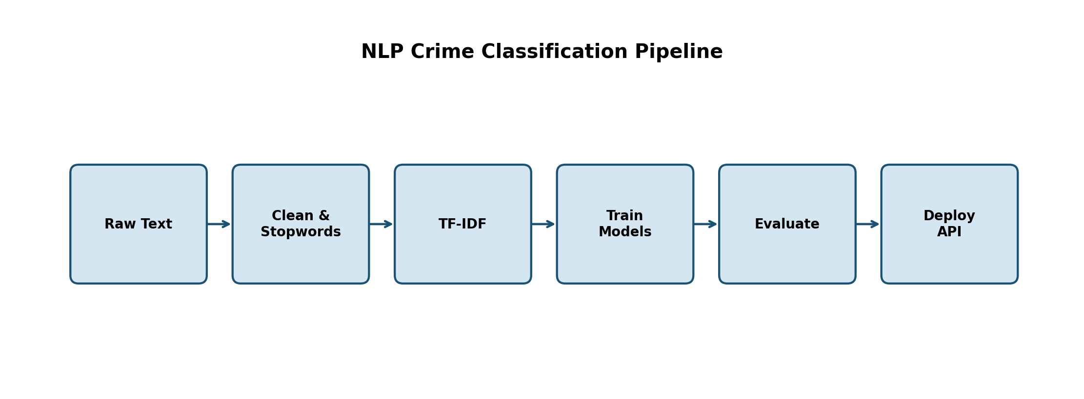
Figure 3.3: NLP Crime Classification Pipeline

3.8 Requirements

3.8.1 System Requirements

Hardware Requirements
The hardware requirements define the minimum physical resources needed to develop, train, and run the application efficiently.
Table 3.4: Hardware Requirements
Component | Minimum Specification
Processor | Intel Core i5 (or equivalent) and above
Memory (RAM) | 8 GB minimum; 16 GB recommended for training
Storage | 20 GB free disk space
Display | 1366 × 768 or higher
Network | Stable internet connection for APIs and scraping

Software Requirements
Table 3.5: Software Requirements
Category | Tools / Technologies
Operating Systems | Windows 10/11, Linux, or macOS
IDE / Editors | Visual Studio Code, Jupyter Notebook
Programming Languages | JavaScript (Node.js), Python 3.x
Frontend | React 19, Vite, Tailwind CSS, Axios, Recharts
Backend | Express 5, Mongoose, JWT, Multer, Puppeteer, Cheerio
ML / NLP | scikit-learn, pandas, numpy, joblib, Flask
Database | MongoDB
Version Control | Git

3.8.2 User Requirements

3.8.2.1 Functional Requirements
FR1: The system shall allow users to submit text for crime classification.
FR2: The system shall accept URL and file inputs and extract readable text.
FR3: The system shall return prediction label and confidence score.
FR4: The system shall authenticate users and enforce role-based access.
FR5: The system shall create investigation cases for crime detections.
FR6: The system shall allow investigators to claim and update cases.
FR7: The system shall support blacklist CRUD and monitoring scans.
FR8: The system shall notify relevant users when crimes are detected.
FR9: The system shall provide an admin dashboard and audit logs.
FR10: The system shall allow flagging of false or malicious reports.

3.8.2.2 Non-Functional Requirements
NFR1 (Performance): Classification responses should return within a few seconds under normal load.
NFR2 (Usability): Interfaces should be clear for non-technical investigators.
NFR3 (Reliability): Analysis history and case records must be persisted durably.
NFR4 (Security): Passwords are hashed; API routes are JWT-protected where required.
NFR5 (Scalability): Services are modular so model and API can scale separately.
NFR6 (Maintainability): Code is organised by controllers, models, routes, and services.
NFR7 (Portability): The stack runs on common desktop operating systems.

3.9 Feasibility Study

3.9.1 Technical Feasibility
The project is technically feasible because all required tools are open-source and widely documented. React, Express, Flask, scikit-learn, and MongoDB are mature technologies already familiar to Computer Applications students. Model training on approximately 10,000 text samples is computationally practical on a standard laptop.

3.9.2 Economic Feasibility
Development relied on free software stacks and publicly available dataset construction effort. No commercial NLP API subscription is required for the core classifier, which makes the solution economically suitable for low-resource institutional settings.

3.9.3 Operational Feasibility
Operationally, BAREAI maps directly onto existing investigative workflows: intake, triage, assignment, and reporting. Role-based screens reduce training overhead for admins and investigators.

3.9.4 Schedule Feasibility
The work was organised into literature review, data preparation, model experimentation, backend/frontend development, integration testing, and thesis writing—aligned with the standard FYP academic calendar.

3.10 System Design
System design artefacts include a use-case view of actors and major interactions, and a logical database schema describing MongoDB collections and relationships. Detailed implementation screenshots and runtime results are presented in Chapter IV.

3.10.1 Use Case Diagram
The primary actors are Admin, Investigator, Public User, and the AI Service. Major use cases include classify text report, manage blacklist, claim/investigate case, view dashboard, manage users, flag false reports, and public analysis.

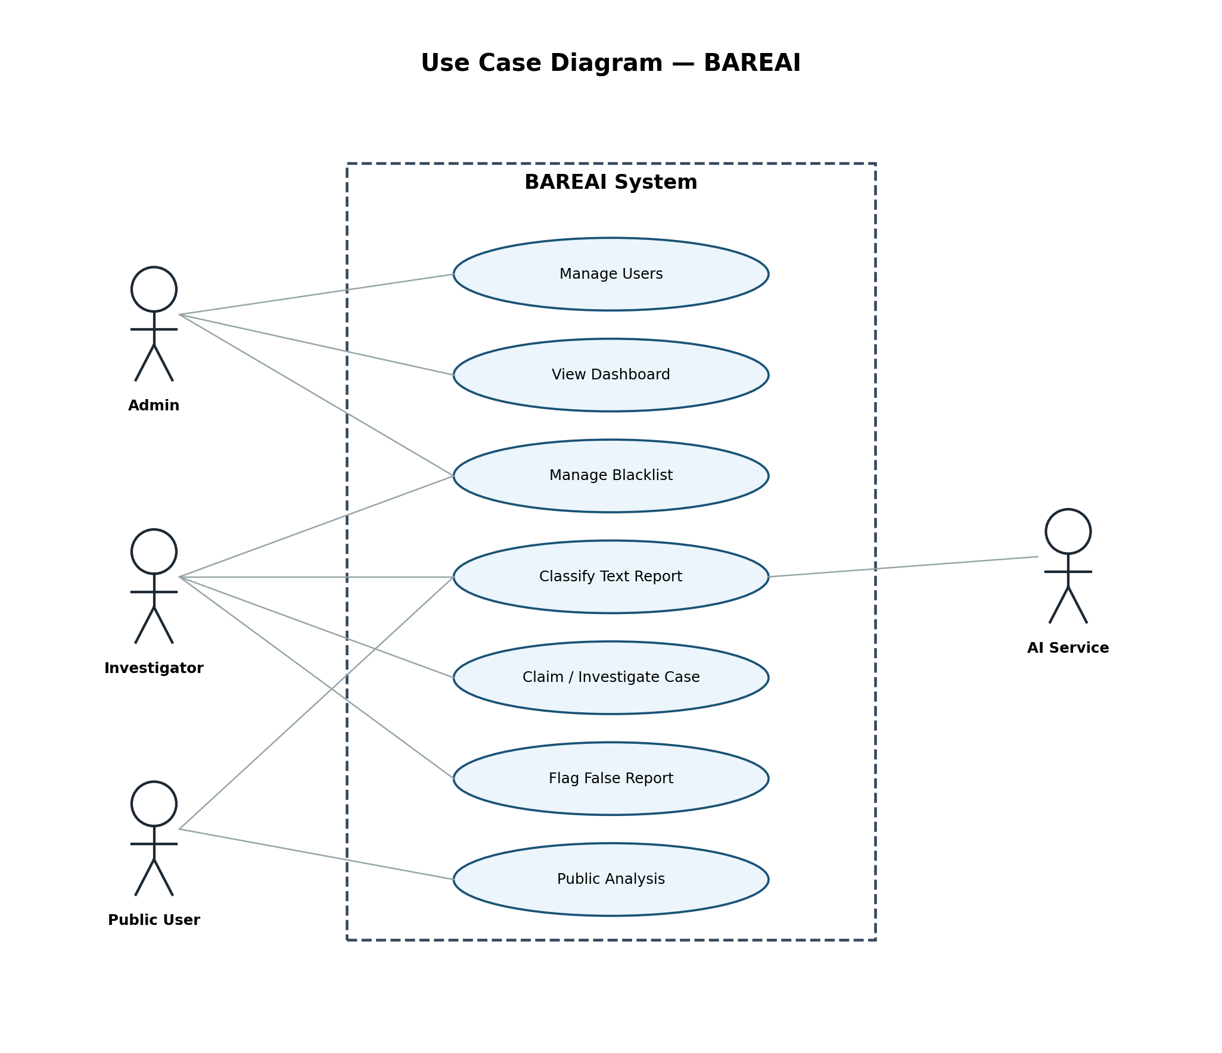
Figure 3.4: Use Case Diagram of BAREAI

3.10.2 Database Design
MongoDB collections were designed around operational entities. User stores identity and role fields. History stores each analysis event. InvestigationCase links one-to-one with a crime History record and tracks assignment status. BlacklistItem defines monitored sources. Notification and ActivityLog support communication and auditing. InvestigationReport stores investigator findings. Relationships are enforced logically through foreign-key style ObjectId references.

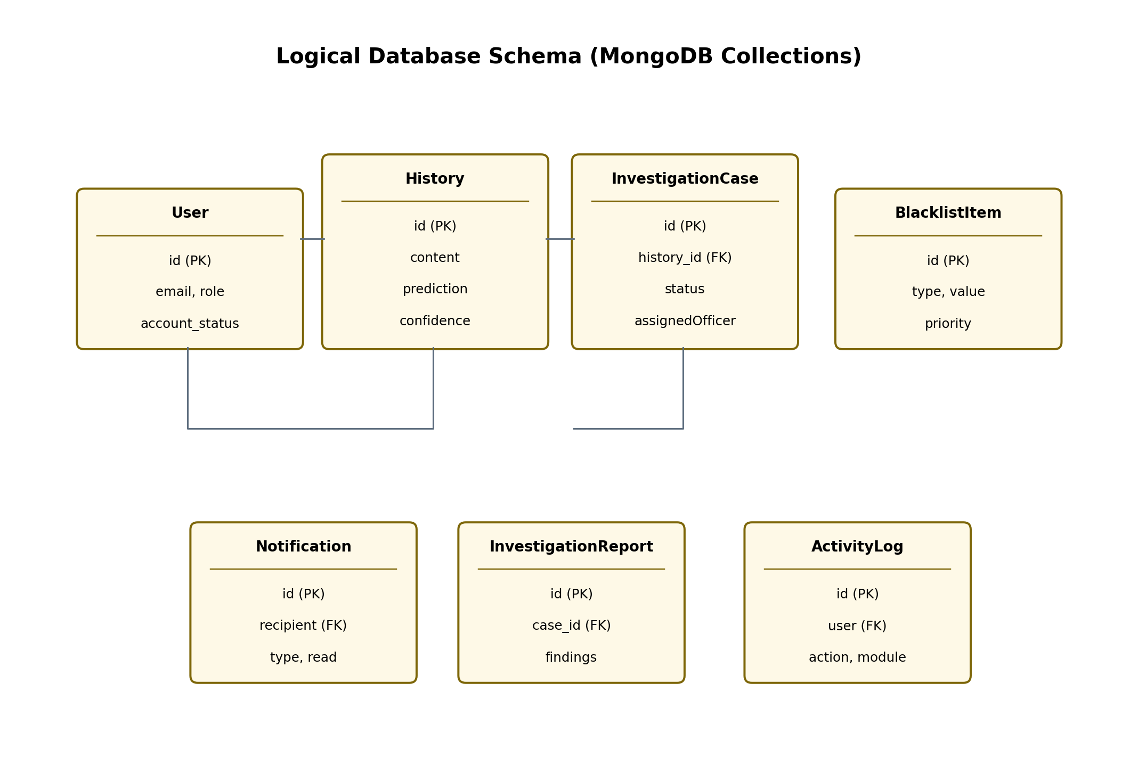
Figure 3.5: Logical Database Schema of BAREAI
Table 3.6: Database Collections Summary
Collection | Key Fields | Purpose
User | email, role, account_status | Authentication and RBAC
History | content, prediction, confidence | Analysis archive
InvestigationCase | history, status, assignedOfficer | Case workflow
InvestigationReport | case, findings, status | Formal reports
BlacklistItem | type, value, priority | Watchlist monitoring
Notification | recipient, type, read | In-app alerts
ActivityLog | action, module, user | Audit trail

CHAPTER IV: IMPLEMENTATION AND RESULTS

4.1 Dataset Description
The dataset used for training and evaluation consists of 9,999 Somali-oriented text entries organised as rows with URL, text, and category attributes. Labels are binary and nearly balanced, which reduces the need for aggressive resampling. Examples include news-style narratives and social posts discussing incidents that may or may not constitute criminal activity. Average document length is about 277 words, with substantial variance, reflecting real-world textual heterogeneity.

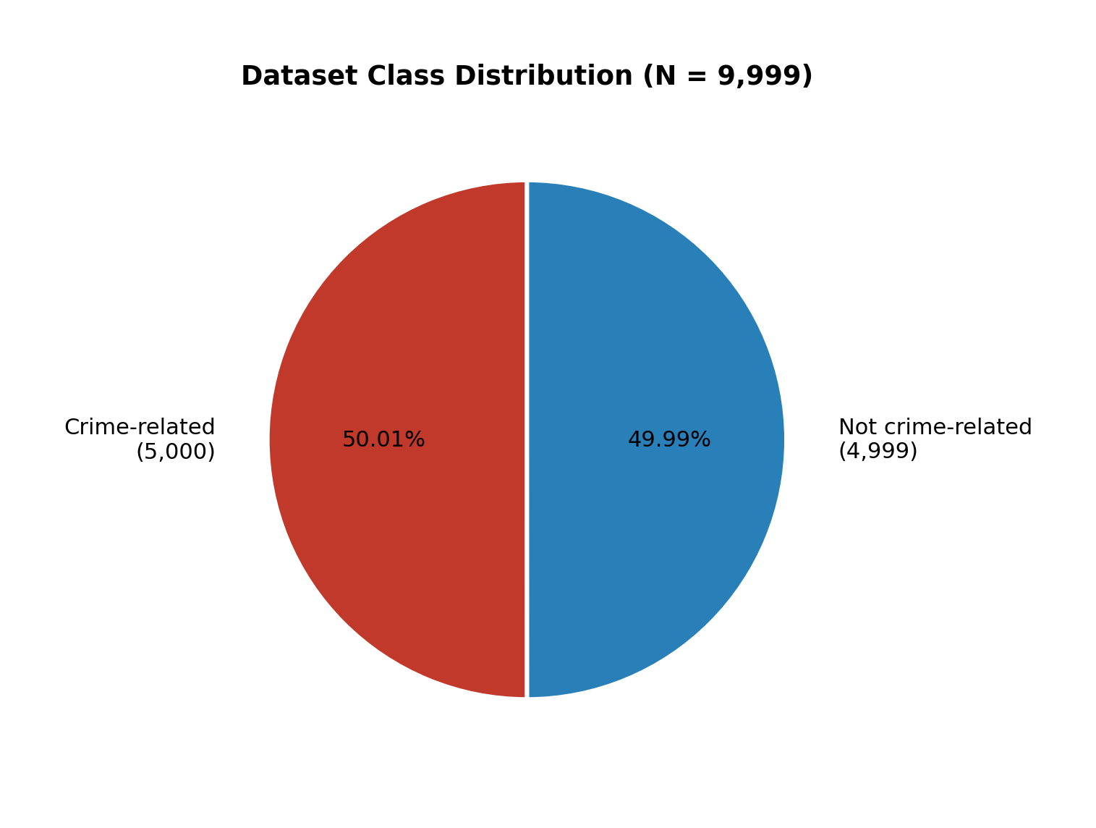
Figure 4.1: Dataset Class Distribution (N = 9,999)

4.2 ML Pipeline Implementation
The machine learning pipeline was developed through a structured process that included data loading, cleaning, stopword removal, TF-IDF vectorisation, stratified splitting, multi-model training, metric comparison, model selection, serialisation, and API deployment. Training and testing were performed on disjoint subsets to assess generalisation. The final Random Forest classifier was validated on the 2,000-sample test set and then packaged for Flask inference.
At runtime, the Flask service transforms incoming text with the saved TF-IDF vectorizer, obtains class probabilities from Random Forest, and applies Somali crime-keyword overrides when explicit high-risk terms are present. Location mentions are extracted with pattern matching against known Somali place names. The Express layer stores the enriched response and triggers case creation when isCrime is true.

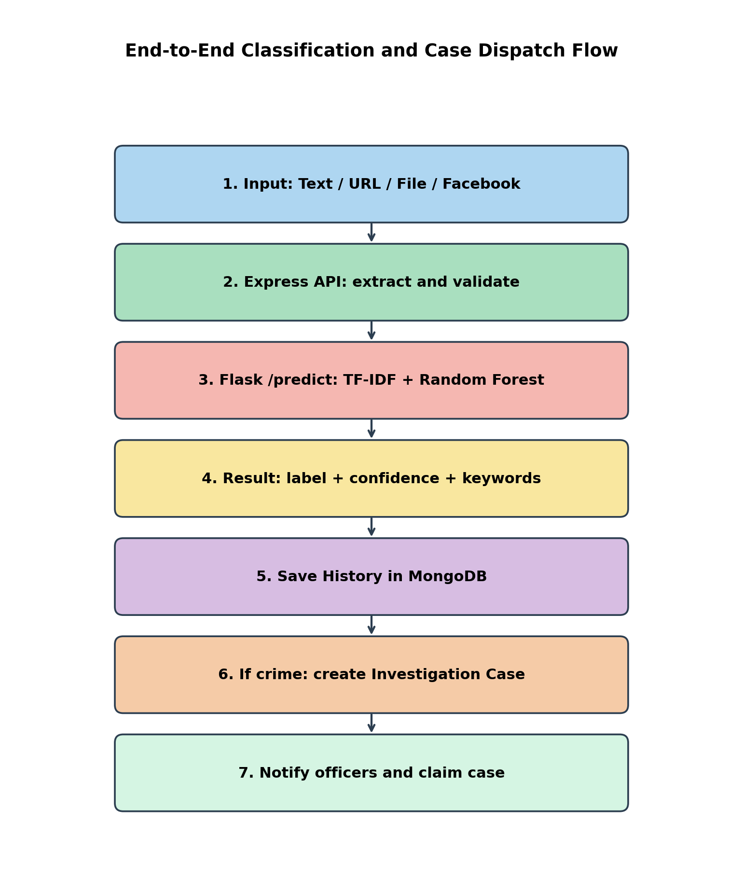
Figure 4.2: End-to-End Classification and Case Dispatch Flow


Figure 4.3: ML Pipeline Implementation Stages

4.3 System Design and Deployment

4.3.1 Backend Implementation
The backend is implemented in Node.js using Express. Key route groups include /api/auth, /api/analysis, /api/investigation, /api/blacklist, /api/dashboard, /api/notifications, /api/reports, /api/users, and /api/audit-logs. Controllers coordinate validation, AI inference calls, MongoDB persistence, and notification dispatch. Background Facebook monitoring uses Puppeteer; website scanning uses Cheerio with SSRF-safe fetching.

4.3.2 Frontend Implementation
The frontend is a React SPA with role-aware routing. Public users access landing and analysis pages. Investigators focus on cases, blacklist tools, and reports. Admins access the dashboard, user management, and audit logs. Charts are rendered with Recharts, and PDF exports are supported where reporting is required.

4.3.3 AI Service Integration
The Flask service listens on port 5001 by default and exposes /health and /predict. The Express backend communicates with AI_MODEL_URL, keeping the browser isolated from direct model access. This improves security and allows independent redeployment of the classifier.

4.3.4 Deployment Topology
In the local development and demonstration environment, the frontend runs on port 5173, the Express API on port 5000, and the Flask model service on port 5001, with MongoDB as the shared database. The same topology can be migrated to a cloud host by containerising each service.

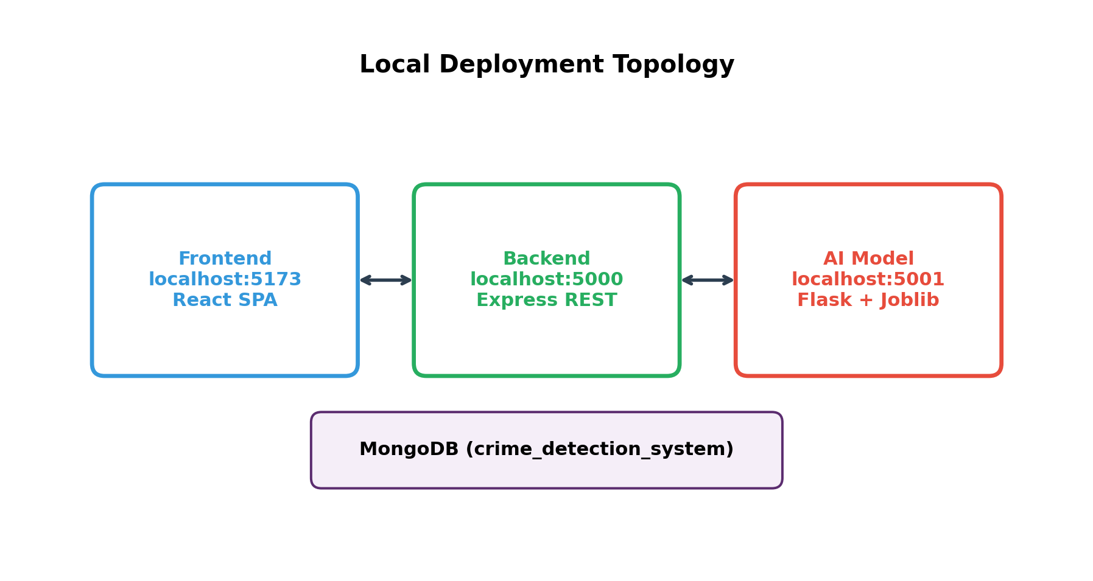
Figure 4.4: Local Deployment Topology of BAREAI Services

4.3.5 Implemented User Interface Modules
The following interface modules were implemented and tested during system integration:
Table 4.1: Implemented Interface Modules
Module | Primary Users | Description
Landing / Public Analysis | Public users | Submit text/URL/file for classification
Admin Dashboard | Admin | Operational KPIs and trends
User Management | Admin | Create and manage accounts/roles
Case Management | Admin, Investigator | Claim, update, and close cases
Blacklist / Monitoring | Admin, Investigator | Watch Facebook/websites/keywords
Reports & Audit Logs | Admin, Investigator | Accountability and analytics
Profile & Settings | All authenticated | Account and preference management

Representative interface screens of the implemented system are shown below. These illustrate the administrator dashboard, the analysis result view returned after NLP inference, and the investigation case board used by officers.

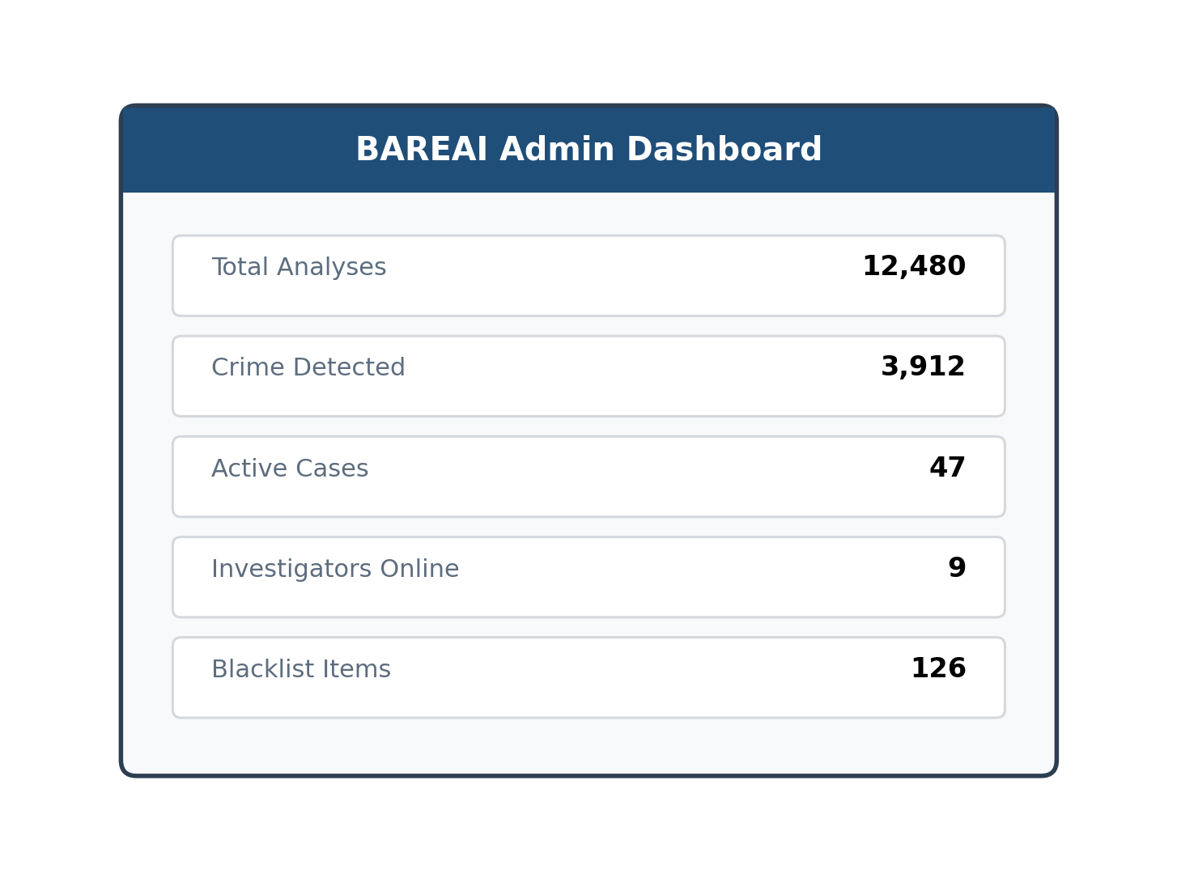
Figure 4.5: Administrator Dashboard Interface (BAREAI)

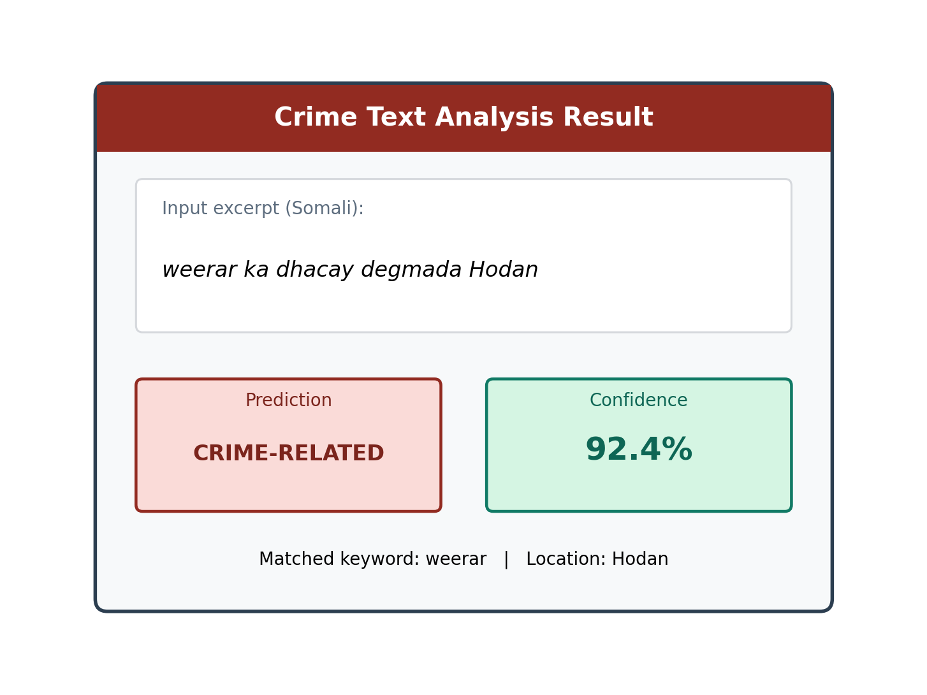
Figure 4.6: Crime Text Analysis Result Interface

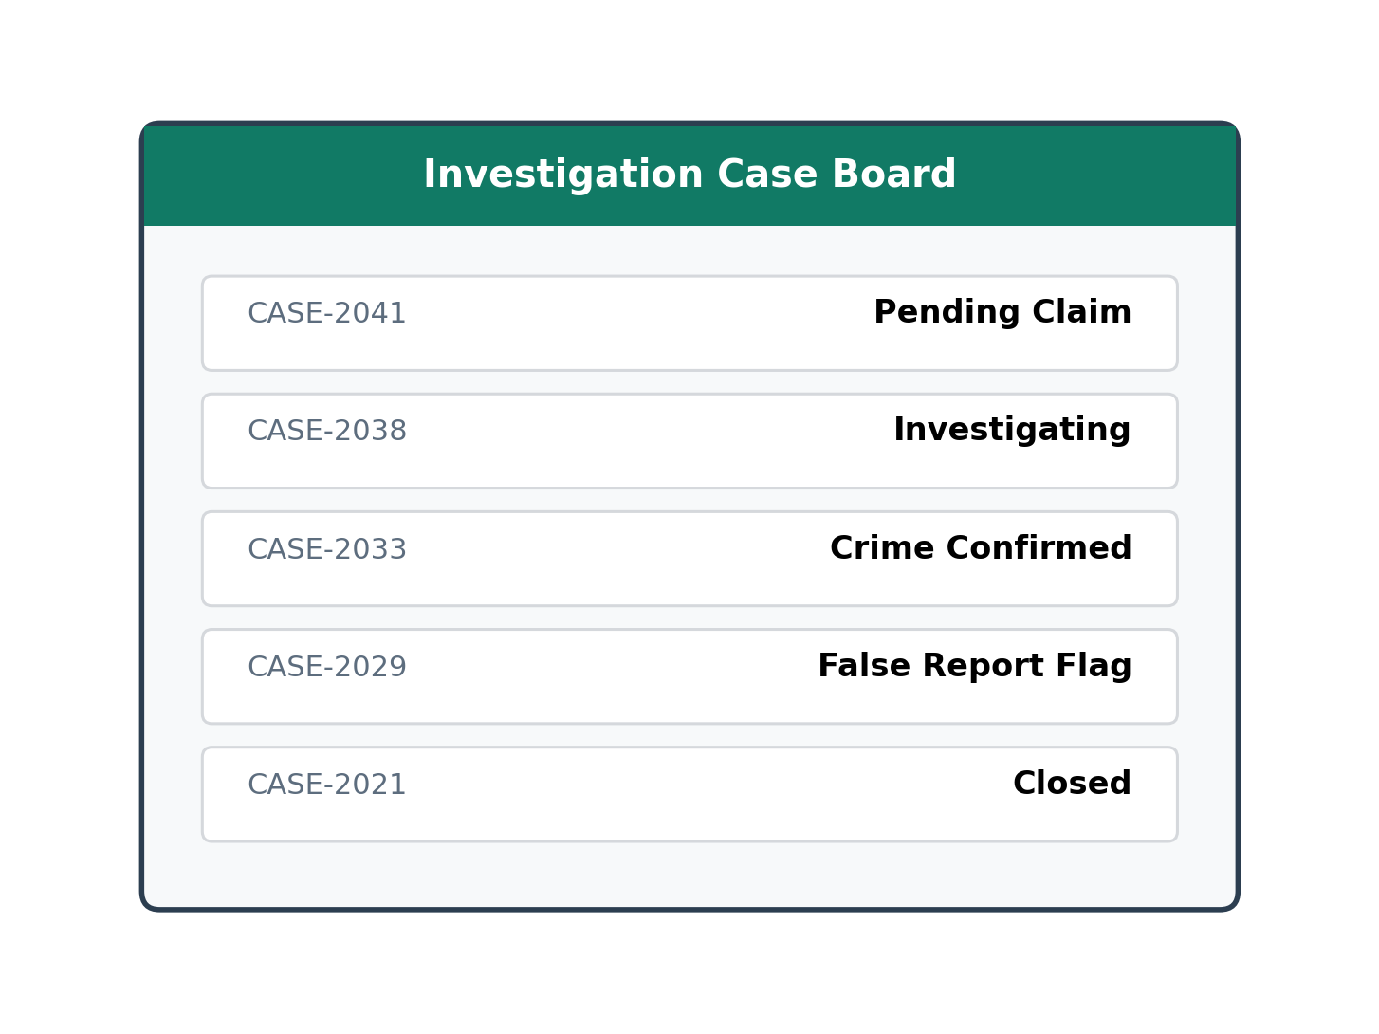
Figure 4.7: Investigation Case Management Interface

4.4 Data Visualization (Results Presentation)
Experimental results are summarised using comparative charts, a confusion matrix, and metric bars for the best model. Random Forest achieved 89.55% across Accuracy, Precision, Recall, and F1-score on the test set. Approximate confusion-matrix cell counts for a balanced 2,000-sample test partition are shown to illustrate error distribution under near-symmetric performance.

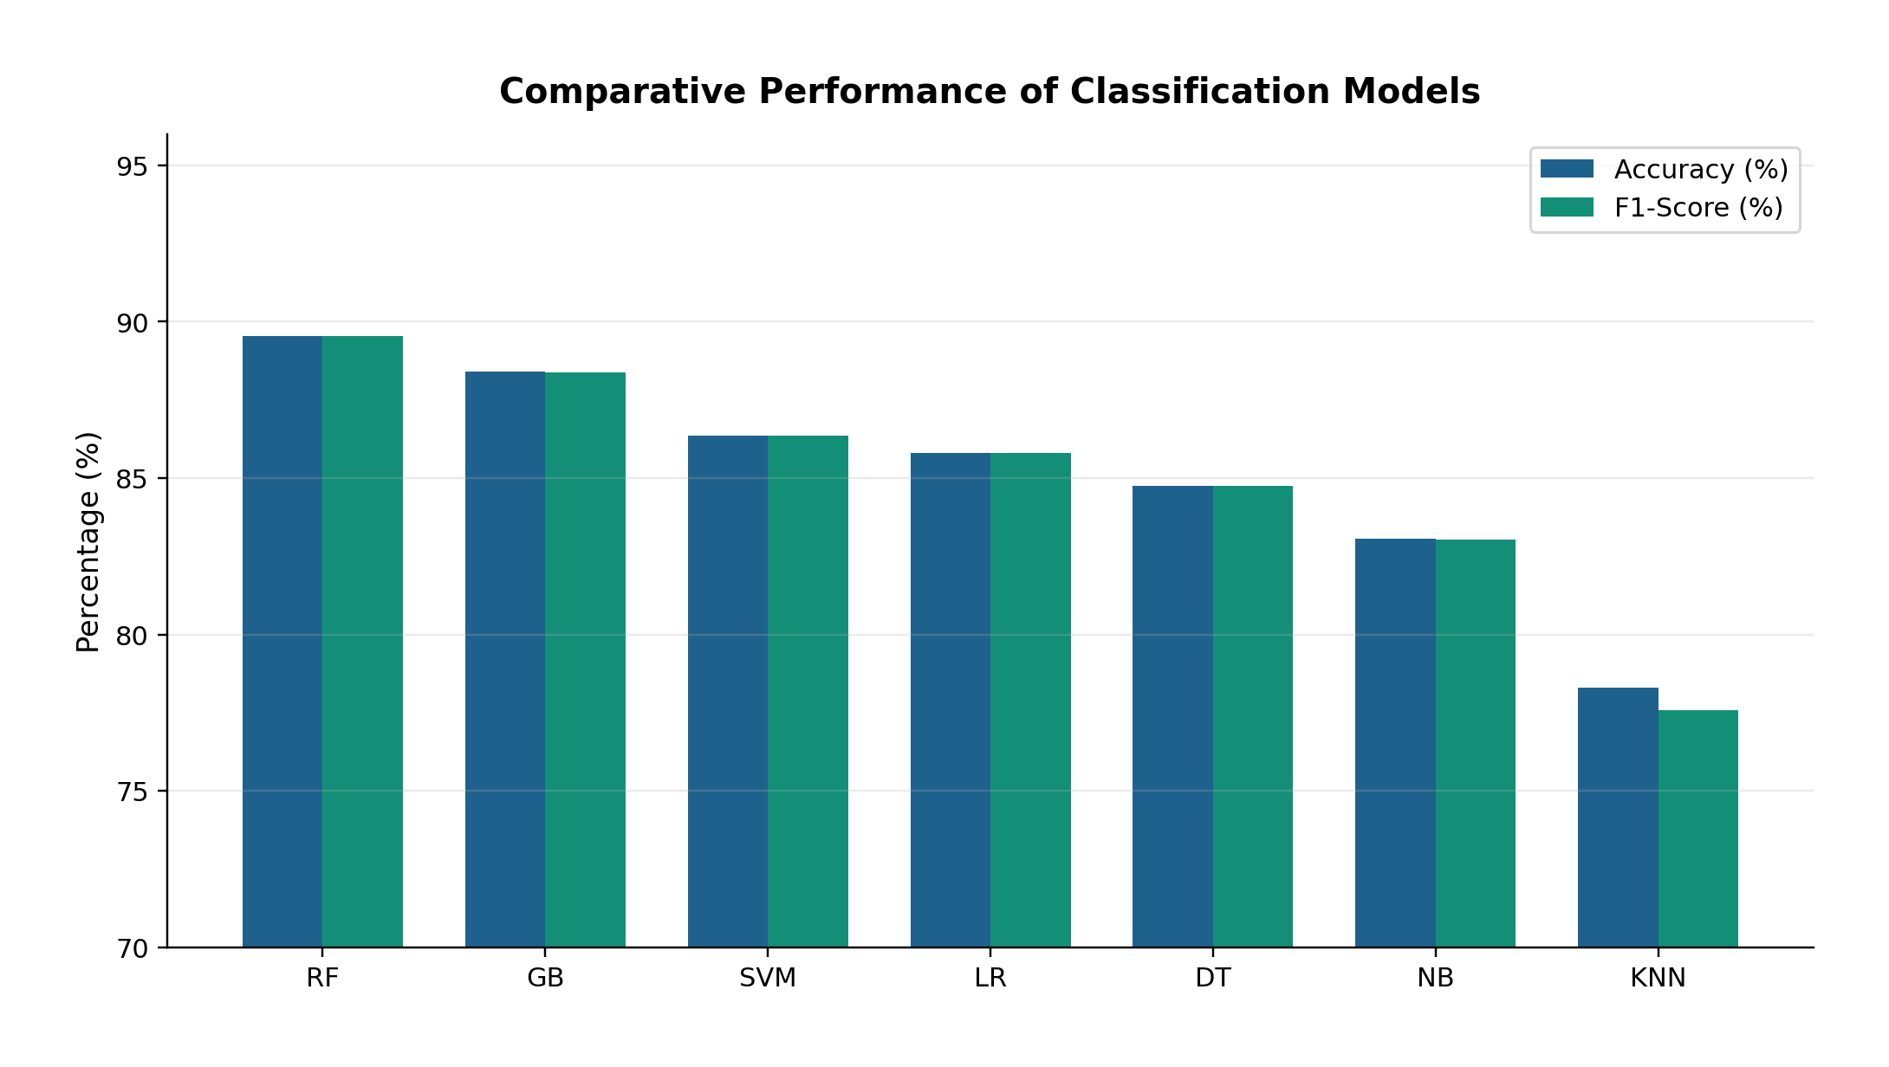
Figure 4.8: Comparative Performance of Classification Models

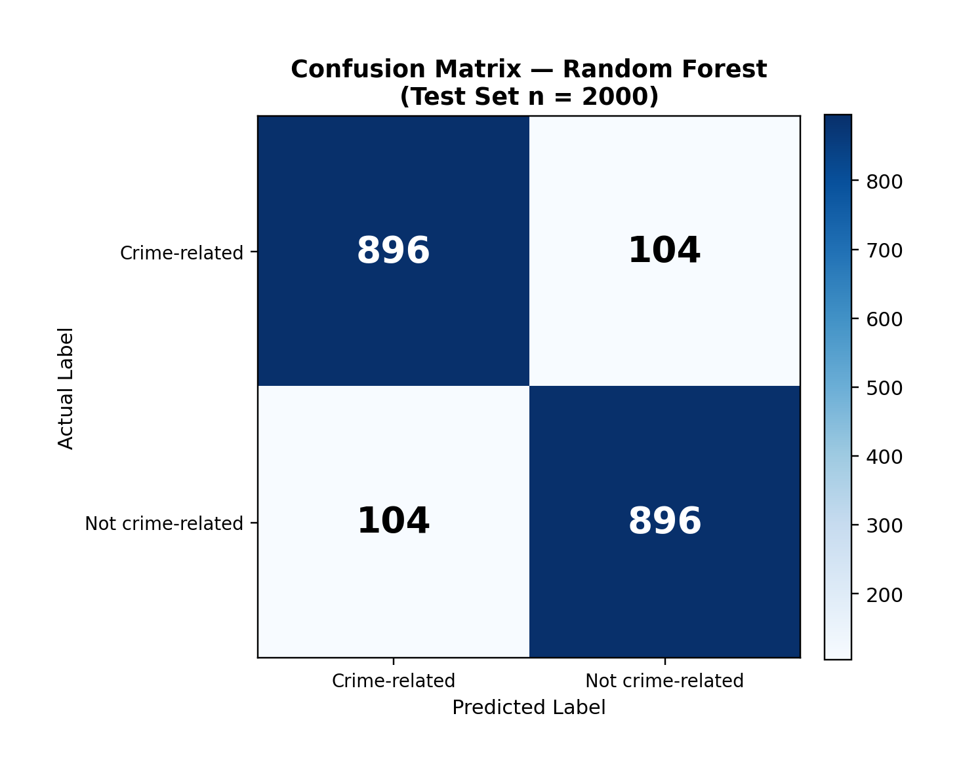
Figure 4.9: Confusion Matrix of the Random Forest Classifier

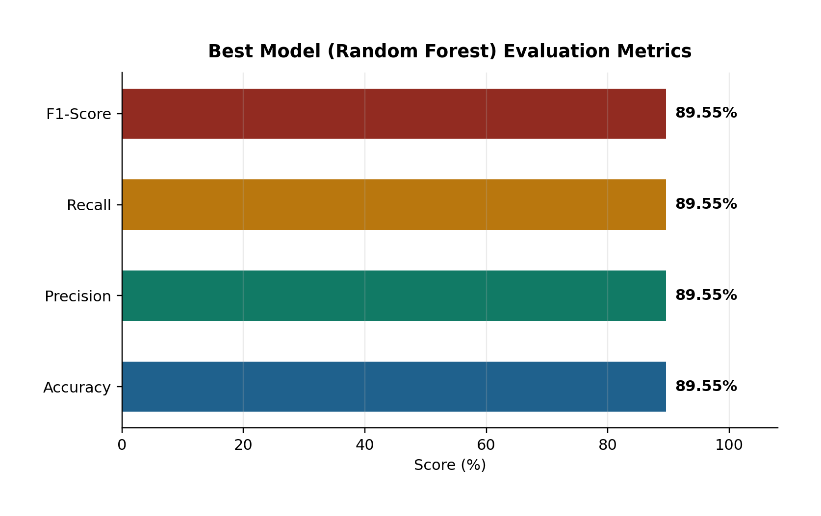
Figure 4.10: Evaluation Metrics of the Selected Random Forest Model

4.5 Model Comparison
Table 4.2 consolidates the comparative evaluation. Random Forest outperformed all baselines, exceeding Gradient Boosting by about 1.15 percentage points in accuracy and outperforming Linear SVM by about 3.20 percentage points. Tree ensembles were particularly effective for TF-IDF features of Somali crime text, while K-NN lagged due to high-dimensional sparse representations.
Table 4.2: Ranked Model Comparison Summary
Rank | Model | Accuracy (%) | F1-Score (%) | Remark
1 | Random Forest | 89.55 | 89.55 | Selected for deployment
2 | Gradient Boosting | 88.40 | 88.39 | Strong runner-up
3 | Linear SVM | 86.35 | 86.35 | Competitive linear baseline
4 | Logistic Regression | 85.80 | 85.80 | Fast interpretable baseline
5 | Decision Tree | 84.75 | 84.75 | Weaker generalisation
6 | Naive Bayes | 83.05 | 83.04 | Strong speed, lower score
7 | K-NN | 78.30 | 77.57 | Least suitable

Beyond offline metrics, system-level testing confirmed that the deployed hybrid pipeline (Random Forest + TF-IDF + keyword enrichment) successfully classifies live inputs and integrates with case management. This demonstrates that the research objectives—reducing manual triage, preprocessing crime text, extracting features, and delivering an automated NLP system—were achieved in a working prototype.

CHAPTER V: DISCUSSION AND CONCLUSION

5.1 Introduction
This chapter interprets the experimental and implementation findings of the study, relates them to the research objectives and questions, discusses contributions, acknowledges limitations, and presents recommendations for future work. It concludes with the main takeaway of the BAREAI project.

5.2 Interpretation of Results
The study set out to develop an intelligent automated framework that uses machine learning and NLP to classify crime-related text reports. The best model, Random Forest, reached 89.55% Accuracy/Precision/Recall/F1 on a balanced held-out test set. This indicates that classical TF-IDF features, when paired with an ensemble classifier, can capture discriminative lexical patterns in Somali crime-related narratives without requiring large transformer models.
In relation to the research questions: (1) manual classification reliance is reduced by providing an automated prediction with confidence and case dispatch; (2) data were successfully collected and preprocessed through cleaning, stopword removal, and normalisation; (3) TF-IDF feature extraction produced representations that support accurate classification; and (4) a complete NLP-enabled web system was developed and integrated with monitoring and investigation workflows.
Compared with weaker baselines such as K-NN (78.30% accuracy), the selected model offers a practically meaningful improvement for triage. The near equality of precision and recall suggests balanced behaviour across crime and non-crime classes, which is desirable when both false alarms and missed crimes are costly.

5.3 Contribution to Knowledge
The main contributions of this FYP are as follows:
A Somali-oriented labelled corpus of nearly 10,000 texts for binary crime-related classification.
An empirical comparison of seven classical classifiers showing Random Forest as the strongest performer at 89.55% F1-score.
A production-style three-tier architecture (React–Express–Flask–MongoDB) that connects NLP inference to operational investigation workflows.
Practical monitoring features (Facebook/website blacklist scanning) that extend classification beyond one-off manual paste inputs.
A case-claiming and notification mechanism that demonstrates how AI predictions can support law-enforcement triage in low-resource settings.

5.4 Challenges and Limitations
Several challenges and limitations were encountered. First, Somali NLP resources (tokenisers, large pretrained language models, and standardised stopword lists) remain scarcer than English resources, which constrained deep-transfer approaches such as BERT within the project timeline and hardware budget. Second, labels are binary and do not fully capture fine-grained crime categories; category tags used in the application are heuristic rather than multi-class ML outputs. Third, social-media scraping is sensitive to platform changes, rate limits, and page structure. Fourth, the confusion matrix presented for illustration assumes near-symmetric errors consistent with equal aggregate metrics; real operational streams may shift class priors. Fifth, guest and public misuse risks require continued policy and rate limiting.

5.5 Future Work
Future research and development may extend BAREAI in the following directions:
Increase dataset size and diversity (dialects, code-mixing, informal chat text).
Train multi-class crime-type models (homicide, theft, cybercrime, etc.).
Evaluate transformer-based Somali/multilingual encoders (e.g., BERT variants) when compute allows.
Improve explainability with feature-importance or token-level highlights for investigators.
Deploy on secure cloud infrastructure with continuous model monitoring and retraining.
Integrate with official policing databases under appropriate legal and ethical frameworks.
Strengthen adversarial robustness against obfuscated crime language.

5.6 Final Conclusion
This study designed, implemented, and evaluated BAREAI, an AI-based system for automatic classification of crime-related text reports using NLP. Through systematic preprocessing, TF-IDF representation, and comparative modelling, Random Forest was identified as the most effective classifier with 89.55% test performance. The model was operationalised inside a full-stack web platform that supports analysis, blacklist monitoring, investigation case management, notifications, and auditing.
The take-home contribution is practical: Somali crime-text triage can be accelerated by a lightweight, transparent ML pipeline embedded in investigator-facing software. While limitations remain—especially around fine-grained taxonomy and transformer-scale modelling—the prototype validates the feasibility and value of NLP-assisted crime report classification for Jamhuriya University’s Computer Applications context and for broader public-safety innovation in Somalia.
In summary, the research objectives were met: reliance on purely manual sorting was reduced; crime-related text data were collected and preprocessed; discriminative features were extracted and analysed; and an automated NLP system was developed, tested, and demonstrated as a working FYP product.

APPENDIX A: FIGURE INDEX
Figure 3.1: System Architecture of the BAREAI Crime Classification Platform
Figure 3.2: Text Preprocessing Flowchart
Figure 3.3: NLP Crime Classification Pipeline
Figure 3.4: Use Case Diagram of BAREAI
Figure 3.5: Logical Database Schema of BAREAI
Figure 4.1: Dataset Class Distribution (N = 9,999)
Figure 4.2: End-to-End Classification and Case Dispatch Flow
Figure 4.3: ML Pipeline Implementation Stages
Figure 4.4: Local Deployment Topology of BAREAI Services
Figure 4.5: Administrator Dashboard Interface (BAREAI)
Figure 4.6: Crime Text Analysis Result Interface
Figure 4.7: Investigation Case Management Interface
Figure 4.8: Comparative Performance of Classification Models
Figure 4.9: Confusion Matrix of the Random Forest Classifier
Figure 4.10: Evaluation Metrics of the Selected Random Forest Model

APPENDIX B: TABLE INDEX
Table 3.1: Dataset Column Description and Summary Statistics
Table 3.2: Feature Engineering and Split Configuration
Table 3.3: Model Evaluation Results on the Test Set
Table 3.4: Hardware Requirements
Table 3.5: Software Requirements
Table 3.6: Database Collections Summary
Table 4.1: Implemented Interface Modules
Table 4.2: Ranked Model Comparison Summary

REFERENCES
Hariguna, T., & Ruangkanjanases, A. (2023). Adaptive Decision-Support System Model for Automated Analysis and Classification of Crime Reports for E-Government. Journal of Applied Data Sciences, 4(3), 303–316. https://doi.org/10.47738/jads.v4i3.127 Khan, N., Islam, S., Chowdhury, F., Siham, A., & Sakib, N. (2022, December 19). Bengali Crime News Classification Based on Newspaper Headlines using NLP. https://doi.org/10.1109/ICCIT57492.2022.10055391 Lombo, X., Oyelade, O. N., & Ezugwu, A. E. (2022). Crime Detection and Analysis from Social Media Messages Using Machine Learning and Natural Language Processing Technique. In O.
Misra, A. M. A. C. Rocha, & C. Garau (Eds.), Computational Science and Its Applications – ICCSA 2022 Workshops (pp. 502 –517). Springer International Publishing. https://doi.org/10.1007/978-3-031-10548-7_37
Martínez Hernández, L. A., Sandoval Orozco, A. L., & García Villalba, L. J. (2026). Use of Natural Language Processing Techniques for Forensic Analysis in Spanish. Engineering Proceedings, 123(1), 15. https://doi.org/10.3390/engproc2026123015 Mussiraliyeva, S., & Baispay, G. (2024). Leveraging Machine Learning Methods for Crime Analysis in Textual Data. International Journal of Advanced Computer Science and Applications (IJACSA), 15(4). https://doi.org/10.14569/IJACSA.2024.0150424 Park, Y., Park, R. S., & Kim, H. (2024). Key Information Extraction for Crime Investigation by Hybrid Classification Model. Electronics, 13(8), 1525.
https://doi.org/10.3390/electronics13081525 Taha, K., Yoo, P. D., Yeun, C., & Taha, A. (2024). A Comprehensive Survey of Text Classification Techniques and Their Research Applications: Observational and Experimental Insights. Computer Science Review, 54, 100664. https://doi.org/10.1016/j.cosrev.2024.100664 Carnaz, G., Antunes, M., & Nogueira, V. B. (2021). An Annotated Corpus of Crime -Related Portuguese Documents for NLP and Machine Learning Processing. Data, 6(7), 71. https://doi.org/10.3390/data6070071 Ali, A., Noah, S. A. M., & Zakaria, L. Q. (2023). A BERT-Based model: Improving Crime News Documents Classification through Adopting Pre -trained Language Models. In Review. https://doi.org/10.21203/rs.3.rs-2582775/v1 Rani, N., Singh, D., Saha, B., & Shukla, S. K. (2024). Automated Classification of Cybercrime Complaints Using Transformer -Based Language Models For Hinglish Text. Arxiv https://doi.org/10.48550/arXiv.2416614 Abdalrdha, Z. K., Al -Bakry, A. M., & Farhan, A. K. (2023). A Survey on Cybercrime Using Social Media. Iraqi Journal for Computers and Informatics, 49(1), 52 –65. https://doi.org/10.25195/ijci.v49i1.404
Abhishek Kumar and S. K. B. (2025). Impact of Social Media on Crime: A Multifaceted Analysis. https://doi.org/10.5281/ZENODO.15642597 Al-harbi, N. K., & Alghieth, M. (2025). Assessing BERT -based models for Arabic and lowresource languages in crime text classification. PeerJ Computer Science, 11, e3017. https://doi.org/10.7717/peerj-cs.3017 Alnaqbi, H. H., & Ali, E. A. M. (2025). Social media impact on societal security. Frontiers in Sociology, 10, 1508542. https://doi.org/10.3389/fsoc.2025.1508542 Altayeva, A., Abdrakhmanov, R., Toktarova, A., & Tolep, A. (2024). Cyberbullying Detection on Social Networks Using a Hybrid Deep Learning Architecture Based on Convolutional and Recurrent Models. International Journal of Advanced Computer Science and Applications, 15(10). https://doi.org/10.14569/IJACSA.2024.0151018 Apene, O. Z., Blamah, N. V., & Aimufua, G. I. O. (2024). Advancements in Crime Prevention and Detection: From Traditional Approaches to Artificial Intelligence Solutions. European Journal of Applied Science, Engineering and Technology, 2(2), 285 –297. https://doi.org/10.59324/ejaset.2024.2(2).20 Belhadj Ali, C. (2021). International crimes in the digital age: Challenges and opportunities shaped by social media. Groningen Journal of International Law, 9(1), 43– 59.https://doi.org/10.21827/grojil.9.1.43-59
Benard, M. C., Charles, M., Charo, J. S., & Mvurya, Dr. M. (2021). Cyber-Crimes Issues on Social Media Usage Among Higher Learning Institutions Students in Dar ES Salaam Region, Tanzania. International Journal of Scientific Research in Science, Engineering and Technology, 138–148. https://doi.org/10.32628/IJSRSET218418 Bifari, E., Basbrain, A., Mirza, R., Bafail, A., Albaradei, S., & Alhalabi, W. (2024). Text mining and machine learning for crime classification: Using unstructured narrative court documents in police academic. Cogent Engineering, 11(1), 2359850. https://doi.org/10.1080/23311916.2024.2359850
Birks, D., Coleman, A., & Jackson, D. (2020). Unsupervised identification of crime problems from police free-text data. Crime Science, 9(1), 18. https://doi.org/10.1186/s40163-020-00127-4 Bonisoli, G., Di Buono, M. P., Po, L., & Rollo, F. (2023). DICE: A Dataset of Italian Crime Event News. Proceedings of the 46th International ACM SIGIR Conference on Research and Development in Information Retrieval, SIGIR ’23, 2985 2995.https://doi.org/10.1145/3539618.3591904 Carnaz, G., Antunes, M., & Nogueira, V. B. (2021). An Annotated Corpus of Crime-Related Portuguese Documents for NLP and Machine Learning Processing. Data, 6(7),71.https://doi.org/10.3390/data6070071
Chinedu, P. U., Nwankwo, W., Masajuwa, F. U., & Imoisi, S. (2021). CybercrimeDetection and Prevention Efforts in the Last Decade: An Overview of the Possibilities of Machine Learning Models. Rigeo, 11(7). https://rigeo.org/menuscript/index.php/rigeo/article/view/1636 Crivellari, A., & Ristea, A. (2021). CrimeVec —Exploring Spatial-Temporal Based Vector Representations of Urban Crime Types and Crime-Related Urban Regions. ISPRS 10.3390/ijgi10040210 Ch, R., Gadekallu, T. R., Abidi, M. H., & Al -Ahmari, A. (2020). Computational System to Classify Cyber Crime Offenses using Machine Learning. Sustainability, 12(10), 4087. https://doi.org/10.3390/su12104087 Eldho, J. (2023). Crime Category Classification in San Francisco using Machine Learning Techniques.
Ezekwe, C. I. (2025). INTERNATIONAL JOURNAL OF RESEARCH AND INNOV ATION IN SOCIAL SCIENCE (IJRISS). SSRN Electronic Journal.https://doi.org/10.2139/ssrn.5065151 Gautam, A. K., & Bansal, A. (2022). PERFORMANCE ANALYSIS OF SUPERVISED MACHINE LEARNING TECHNIQUES FOR CYBERSTALKING DETECTION IN SOCIAL MEDIA... Vol., (2).
Hariguna, T., & Ruangkanjanases, A. (2023). Adaptive Decision-Support System Model for Automated Analysis and Classification of Crime Reports for EGovernment. Journal of Applied Data Sciences, 4(3), 303–316.https://doi.org/10.47738/jads.v4i3.127 Hossain, S., Abtahee, A., Kashem, I., Hoque, M. M., & Sarker, I. H. (2020). Crime Prediction Using SpatioTemporal Data. In N.
Chaubey, S. Parikh, & K. Amin (Eds.), Computing Science, Communication and Security (V ol. 1235, pp. 277–289). Springer Singapore. https://doi.org/10.1007/978-981-15-6648-6_22 Kaur, G., Bonde, U., Pise, K. L., Yewale, S., Agrawal, P., Shobhane, P., Maheshwari, S., Pinjarkar, L., & Gangarde, R. (2024). Social Media in the Digital Age: A Comprehensive Review of Impacts, Challenges and Cybercrime. Engineering Proceedings, 62(1), 6. https://doi.org/10.3390/engproc2024062006 Khairova, N., Mamyrbayev, O., Rizun, N., Razno, M., & Galiya, Y. (2023). A Parallel Corpus-Based Approach to the Crime Event Extraction for Low-Resource Languages. IEEE Access, 11, 54093–54111. https://doi.org/10.1109/ACCESS.2023.3281680 Lent, H., Galinkin, E., Chen, Y., Pedersen, J. M., Derczynski, L., & Bjerva, J. (2025). NLP Security and Ethics, in the Wild. Transactions of the Association for Computational Linguistics, 13, 709–743. https://doi.org/10.1162/tacl_a_00762 Martínez Hernández, L. A., Sandoval Orozco, A. L., & García Villalba, L. J. (2026). Use of Natural Language Processing Techniques for Forensic Analysis in Spanish. Engineering Proceedings,123(1), 15. https://doi.org/10.3390/engproc2026123015 Mussiraliyeva, S., & Baispay, G. (2024). Leveraging Machine Learning Methods for Crime
Analysis in Textual Data. International Journal of Advanced Computer Science and Applications, 15(4). https://doi.org/10.14569/IJACSA.2024.0150424 Osho, A., Tucker, E., & Amariucai, G. (2020). Implicit Crowdsourcing for Identifying Abusive Behavior in Online Social Networks (arXiv:2006.11456). arXiv. https://doi.org/10.48550/arXiv.2006.11456 Palanivinayagam, A., El-Bayeh, C. Z., & Damaševičius, R. (2023). Twenty Years of MachineLearning-Based Text Classification: A Systematic Review. Algorithms, 16(5). https://www.mdpi.com/1999-4893/16/5/236 Park, Y., Park, R. S., & Kim, H. (2024). Key Information Extraction for Crime Investigation by Hybrid Classification Model. Electronics, 13(8)1525. https://doi.org/10.3390/electronics13081525 Rani, N., Singh, D., Saha, B., & Shukla, S. K. (2024). Automated Classification of Cybercrime Complaints Using Transformer-Based Language Models For Hinglish Text. Arxiv https://doi.org/10.48550/arXiv.2416614 Ren, Y., Han, J., Lin, Y., Mei, X., & Zhang, L. (2022). An Ontology-Based and Deep LearningDriven Method for Extracting Legal Facts from Chinese Legal Texts. Electronics, 11(12). https://www.mdpi.com/2079-9292/11/12/1821
Rashid, M., Gul, S., & Ullah, M. (2025). The Influence of Social Media on Criminal Behaviour and Public Perception of Crime. 3(4).
Sarzaeim, P., Mahmoud, Q. H., & Azim, A. (n.d.). Experimental Analysis of Large Language Models in Crime Classification and Prediction.
Taskiran, S. F., Turkoglu, B., Kaya, E., & Asuroglu, T. (2025). A comprehensive evaluation of oversampling techniques for enhancing text classification performance. Scientific Reports, 15, 21631. https://doi.org/10.1038/s41598-025-05791-7 Taha, K. (2024). Empirical and Experimental Insights into Data Mining Techniques for Crime Prediction:A Comprehensive Survey (arXiv:2403.00780). arXiv. https://doi.org/10.48550/arXiv.2403.00780 Tuarob, S., Tatiyamaneekul, P., Pongpaichet, S., Tawichsri, T., & Noraset, T. (2025). Beyond administrative reports: A deep learning framework for classifying and monitoring crime and accidents leveraging large-scale online news. Neural Computing and Applications, 37(10), 7183–7205. https://doi.org/10.1007/s00521-024-10833-8 Umair, A., Sarfraz, M. S., Ahmad, M., Habib, U., Ullah, M. H., & Mazzara, M. (2020). Spatiotemporal Analysis of Web News Archives for Crime Prediction. Applied Sciences, 10(22),8220. https://doi.org/10.3390/app10228220
Umeugo, W. (2023). Cybercrime Awareness on Social Media: A Comparison Study. International Journal of Network Security & Its Applications, 15(2), 23 –35. https://doi.org/10.5121/ijnsa.2023.15202 Vieira, A. R., Santos, G. D. S., Melo, W. S., & Rust, L. F. (2025). Hierarchical Multi -Class and Multi-Label Text Classification for Crime Report: A Traditional Machine Learning Approach. IEEE Access, 13, 206431– 206446. https://doi.org/10.1109/ACCESS.2025.3638984 Yadav, N., Kudale, O., Gupta, S., Rao, A., & Shitole, A. (2020). Twitter sentiment analysis using supervised machine learning. In J.
Hemanth, R. Bestak, & J. I. Z. Chen (Eds.), Intelligent Data Communication Technologies and Internet of Things. Springer. https://doi.org/10.1007/978- 98115-9509-7_51 Yin, J. (2022). Crime Prediction Methods Based on Machine Learning: A Survey.
Computers, Materials & Continua, 74(2), 4601–4629. https://doi.org/10.32604/cmc.2023.034190,
Faculty of Computer and Information Technology, Jamhuriya University of Science and Technology. (n.d.). Undergraduate researcher’s compass: A practical guide for final year computer science students (AI based FYPs).

